EXP NO 8: Student Counselling System
Aim:
To create a cloud-based Student Counselling System using Zoho Creator.
Steps:
- Create a new application.
- Create a Student Counselling form.
- Add fields: Student Name, Age, Address, Phone Number, Percentage, Year of Passing, and Domain Interest.
- Create reports to view counselling information.
- Enter sample records and verify the application.
IMPLEMENTATION:
// Student Counselling System

student = insert into Students
[
Student_Name = input.Student_Name
Register_No = input.Register_No
Department = input.Department
Year = input.Year
];

session = insert into Counselling_Session
[
Student_Name = input.Student_Name
Counsellor = input.Counsellor
Session_Date = input.Session_Date
Problem = input.Problem
Status = "Scheduled"
];

if(input.Status == "Completed")
{
input.Status = "Completed";
}

info "Student counselling record saved successfully.";
OUTPUT:
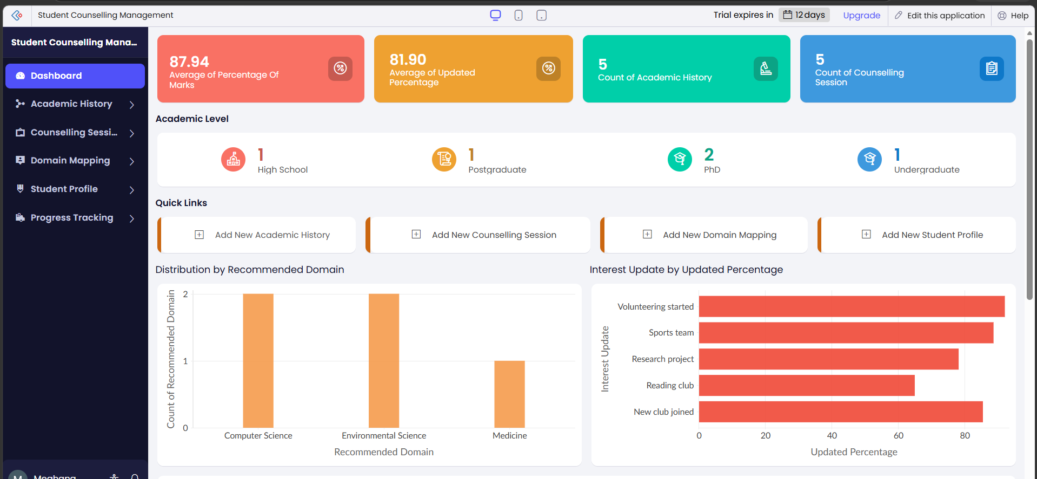
RESULT:
The Student Counselling System was successfully implemented in Zoho Creator to maintain student details, schedule counselling sessions, update session status, and generate counselling records.

